Project Design Phase-II
Data Flow Diagram & User Stories
Date | 12 July 2026
Team ID | [Enter Team ID]
Project Name | Smart Lender – Loan Approval Prediction System
Maximum Marks | 4 Marks

Data Flow Diagram
The Level-0 DFD below shows how applicant data moves through Smart Lender: from the intake form, through the Flask prediction process, to the persisted model artifacts and back out as a decision.
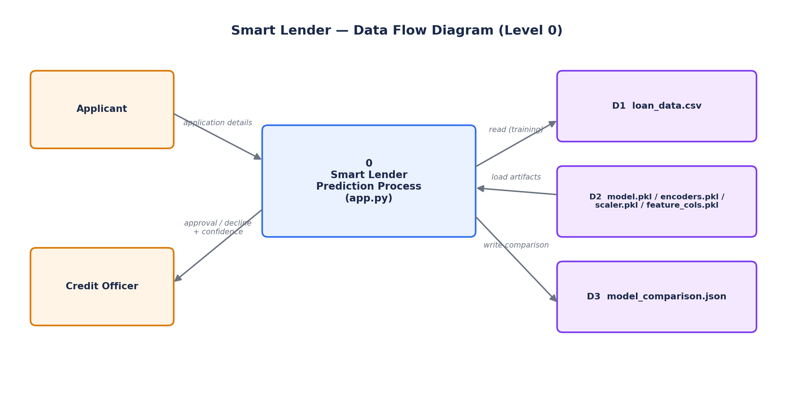

User Stories
User Type | Functional Requirement (Epic) | User Story No. | User Story / Task | Acceptance Criteria | Priority | Release
Credit Officer | Loan Intake | USN-1 | As an officer, I can open the application form and enter an applicant's personal, income and property details. | Form loads at GET / and accepts all required fields | High | Sprint-1
Credit Officer | Loan Intake | USN-2 | As an officer, I get inline validation if a required field (e.g. income) is missing or invalid. | Submitting an incomplete form re-prompts for the missing field | Medium | Sprint-2
Credit Officer | Prediction | USN-3 | As an officer, I can submit the form and receive an instant Approve/Decline decision. | POST /predict returns a rendered result within 2 seconds | High | Sprint-1
Credit Officer | Prediction | USN-4 | As an officer, I can see a confidence percentage and gauge alongside the decision. | Result page shows numeric confidence and a matching gauge needle position | High | Sprint-1
Credit Officer | Prediction | USN-5 | As an officer, I can review the applicant details I submitted on the result page before acting on the decision. | Result page echoes back all submitted fields | Medium | Sprint-2
Data/ML Engineer | Model Training | USN-6 | As an ML engineer, I can retrain on updated data with one command. | Running train_model.py regenerates model/*.pkl and model_comparison.json | High | Sprint-1
Data/ML Engineer | Model Training | USN-7 | As an ML engineer, I can compare accuracy across Decision Tree, Random Forest, KNN and XGBoost before the best one is auto-selected. | model_comparison.json lists train/test accuracy for all four models | High | Sprint-2
Administrator | Deployment | USN-8 | As an administrator, I can deploy the app to IBM Cloud so the whole team can access it. | App runs via gunicorn per the Procfile on Cloud Foundry/Code Engine | Medium | Sprint-3
Loan Applicant | Loan Intake | USN-9 | As an applicant, I want my loan decision communicated quickly and clearly by the officer using the tool. | Officer can produce a decision for a walk-in applicant within the same session | Low | Sprint-3

